Class and Style Binding

Step 1 : create angular project

Step 2 : use command ng g component demo

Step 3 :

App.component.html

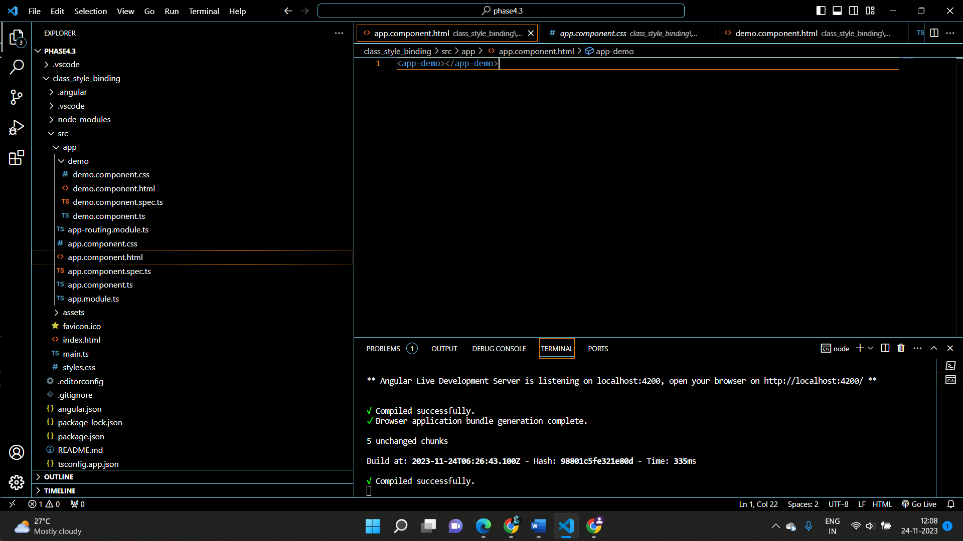

Step 4 :

Demo.component.html

<div class="box" [ngStyle]="mltStyle" [ngClass]="mltclasses">class_style_Binding</div>

Step 5 :

Demo.component.css

.box{

    width: 100px;

    height:100px;

}

Step 6 :

Demo.component.ts

import { Component } from '@angular/core';

@Component({

  selector: 'app-demo',

  templateUrl: './demo.component.html',

  styleUrls: ['./demo.component.css']

})

export class DemoComponent {

mltclasses={

  class1:true,

  class2:true,

  class3:true

}

mltStyle={

  'background' : 'red',

  'border': '10px solid green'

}

}